## **Logistic Regression - One-vs-Rest (OvR) for Multi-Class Classification**

### **1. The Challenge: Multi-Class Classification**

* Standard Logistic Regression is inherently a **binary classifier**, designed to distinguish between two classes (e.g., 0 vs 1, Spam vs Not Spam).
* Many real-world problems involve **multi-class classification**, where an instance needs to be assigned to one of three or more possible categories (e.g., classifying handwritten digits 0-9, identifying different types of flowers, categorizing news articles).

### **2. The One-vs-Rest (OvR) Strategy**

* **Concept:** OvR (also known as One-vs-All or OvA) is a common and intuitive strategy to extend binary classifiers, like Logistic Regression, to handle multi-class problems. It works by decomposing the single multi-class problem into multiple binary classification problems.
* **Mechanism:**
  1. **Decomposition:** If you have K distinct classes in your target variable, the OvR strategy trains K independent binary classifiers.
  2. **Training Classifier k:** For each class k (where k ranges from 1 to K):
     + A binary Logistic Regression model is trained.
     + The goal of this model is to distinguish class k (treated as the "positive" class, label = 1) from **all other classes combined** (treated as the "negative" class, label = 0).
     + **Data Relabeling:** To train classifier k, you temporarily relabel your training data: Assign label 1 to all instances belonging to class k, and label 0 to all instances belonging to any other class (j ≠ k).
  3. **Result:** After training, you have K separate binary logistic regression models. Each model specializes in recognizing *one* specific class compared to all the others.

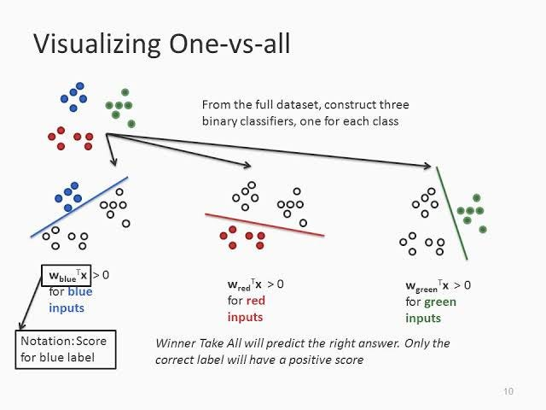

### **3. Making Predictions with OvR**

* To classify a new, unseen data point X:
  1. **Input to all Classifiers:** Pass the features of X to *each* of the K trained binary classifiers.
  2. **Get Probabilities:** Each classifier k outputs a probability score, P(Class k vs Rest | X), which represents the probability that the instance belongs to class k according to that specific binary classifier (trained to separate k from the rest).
  3. **Decision Rule:** Assign the instance X to the class k whose corresponding classifier yields the **highest probability score**. Predicted Class = argmax_k [ P(Class k vs Rest | X) ] (for k from 1 to K)

### **4. Example (3 Classes: Apple, Banana, Cherry)**

1. **Classifier 1 (Apple vs Rest):** Trained on data labeled (Apple=1, Banana=0, Cherry=0). Learns to predict P(Apple vs Rest).
2. **Classifier 2 (Banana vs Rest):** Trained on data labeled (Apple=0, Banana=1, Cherry=0). Learns to predict P(Banana vs Rest).
3. **Classifier 3 (Cherry vs Rest):** Trained on data labeled (Apple=0, Banana=0, Cherry=1). Learns to predict P(Cherry vs Rest).

* **Prediction:** For a new fruit image, you get three probabilities (e.g., P(Apple vs Rest)=0.1, P(Banana vs Rest)=0.7, P(Cherry vs Rest)=0.2). Since the "Banana vs Rest" classifier gave the highest score (0.7), the model predicts "Banana".

### **5. Advantages of OvR**

* **Simplicity & Modularity:** Easy to understand and implement. It directly leverages existing binary classification algorithms without modification.
* **Efficiency:** Requires training only K classifiers. This is generally computationally efficient, especially compared to strategies like One-vs-One for large K.
* **Interpretability (Partial):** The individual classifier scores can sometimes offer insights into how strongly the model associates the input with each class versus all others.

### **6. Disadvantages of OvR**

* **Class Imbalance:** Each binary classifier is trained on potentially skewed data (one class vs. all others). If K is large, the "positive" class might be a small fraction of the data for each classifier, potentially requiring techniques to handle class imbalance during training.
* **Probability Calibration:** The probability scores from the K classifiers are not strictly comparable on the same theoretical scale, as each was trained on a different binary problem. They don't necessarily sum to 1 across the K classifiers. However, the argmax decision rule usually works well empirically.
* **Potential Ambiguity:** In rare cases, multiple classifiers might output the exact same highest probability, leading to ties (though usually handled by tie-breaking rules).

### **7. Comparison to Other Multi-Class Methods**

* **Multinomial Logistic Regression (Softmax Regression):** This is a direct multi-class extension of logistic regression. It trains a single model that simultaneously estimates the probability for all K classes using the Softmax function, ensuring probabilities sum to 1. Often preferred if available and suitable, but OvR allows using *any* binary classifier.
* **One-vs-One (OvO):** Trains K * (K-1) / 2 binary classifiers, one for every pair of classes. Prediction uses a voting scheme among these classifiers. Can be more computationally expensive than OvR if K is large, but sometimes handles certain types of data better.

### **8. When to Use OvR with Logistic Regression**

* It's a standard and straightforward way to apply Logistic Regression (or other binary classifiers like SVM) to multi-class problems.
* Suitable when the number of classes (K) is manageable.
* Often used when a direct multi-class version of the algorithm (like Softmax Regression) is not available or desired.